CS600/700 Series
Upgrading Guidelines (V1.0.0)

Run ‘DMR Upgarde Setup vx.xx.exe’ to install the upgrading tool.

Install the USB driver if not

Then run the upgrading software tool, then
1)Open the upgrading object file;
2)Connect the radio to the PC by the programming cable;
3)Press the PTT & TopKey and then power up the radio;
4)Click ‘Download upgrade file’ button to start upgrading;
5)Wait and until the PC reminde Success or Failure (about 1minute);
6)Power Off the radio.

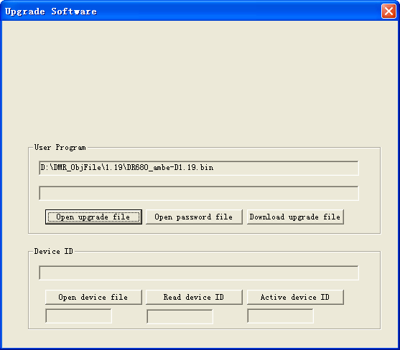

Note:
- Keep the cable connected stably and the radio is power on all the upgrading period.
- The upgarding object file starting with ‘D’ is for LCD version, whereas the ‘d’ for non-LCD version or the same name as your model.
3) Press the PTT & TopKey and then power up the radio!

